A big year: St. Francis High turns 50 and its longtime archivist steps down

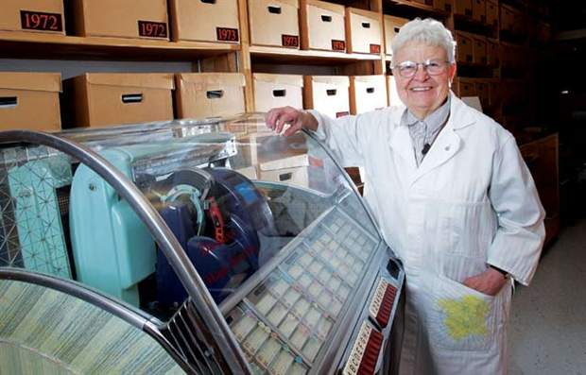
MARCELLO DI CINTIO, SWERVE 10.11.2012

Catherine Mitchell taught my mother biology in the 1960s at St. Francis High School. Three decades later, she taught me. During an open-house event at the school at the beginning of the semester, Mrs. Mitchell held a brief orientation for the parents of her Biology 30 students. She wanted them to know her expectations of the class. My mother arrived late and missed most of the meeting, but she approached Mrs. Mitchell afterwards. “I’m sorry for being late,” my mother said. “I am Marcello’s mom. I don’t know if you remember me, but you were also my teacher many years ago.”
Mrs. Mitchell replied tartly: “If I was your teacher, then you should know not to be late.”
The story would not surprise any of the thousands of students Mrs. Mitchell taught over the years. I remember Mrs. Mitchell well. Everyone did. Since she began at St. Francis in 1967, Mrs. Mitchell was the school’s most feared teacher. She always wore a white lab coat, always looked strict and severe. She expected her students to work hard and, god forbid, learn. I feel sadness that, after 45 years at the school—first as biology teacher, then as the school’s archivist—Mrs. Mitchell will soon leave those familiar hallways for the last time. And I find it both apt and poetic that St. Francis’s most memorable teacher is also the guardian of the school’s collective memory.
Last month, I met Mrs. Mitchell in the school’s archives room. Her hair is shorter and whiter than I remember it, but other than that she has aged little from the days when she taught the ins and outs of the endocrine system to me and my intimidated teenaged classmates. “I never had an unhappy day as a teacher,” she told me. “I bounded out of bed each morning and said ‘Let me at it.’” She understands, however, that she rarely revealed this happiness to her students. “I hardly smiled at anyone,” she said. “I really wasn’t nice to them on a personal basis.”
Mrs. Mitchell makes no apologies for this. She never tried to befriend her students. But she admits her biggest challenge as a teacher was knowing when to be tough and when to soften. She told me a story from early in her career, back in the late 1950s, when she chided a young female student for not completing her homework. The girl looked up at Mrs. Mitchell and said, “If your dad came home dead drunk, and beat you and beat your mother, and you had to spend the night in the garage with four little crying kids, would you have your homework done?” The question silenced Mrs. Mitchell, and she never forgot it. To this day, she recalls the exact spot in the classroom where the girl sat. “It makes you think before you shout out at someone,” Mrs. Mitchell told me. “The hugely difficult thing for me was to know what kid to give a pat on the back, and which kid to give a good swift kick to. Excuse me, that’s not very lady-like, but that is it. And you can destroy a person either way.”
Mrs. Mitchell retired from teaching in 1991, but she never left St. Francis. Immediately after her retirement she returned to the school, donned her lab coat again, and devoted herself to the archives. For more than 20 years she has arrived at the school between 6:30 and 6:45 each morning, long before any teachers or students show up, to collect and sort the history of the school. And she does it for free. After so many years, the school has claimed a part of her. “It’s got me as much as I’ve got it.” For Mrs. Mitchell, the St. Francis narrative is worth telling.
“This is a story written by the kids. I am just the scribbler,” Mrs. Mitchell said, but she has no reason for such modesty; the archive she has amassed is impressive. Racks sag under the weight of ancient polyester sports uniforms and leather “Browns” jackets. There are two file boxes for each of St. Francis High School’s 50 years which stand side by side on a wall of shelves. “Everything went into the ark in twos,” Mrs. Mitchell said. The first box for each year contains materials related to the happenings at the school during that year: programs for assemblies, honour roll lists, sport results, school awards and so on. The second box contains everything Mrs. Mitchell has collected related to the year’s Grade 12 students since their graduation. Mitchell and her beloved husband, Theo, scan newspapers and magazines for news about former St. Francis grads. When she reads about a person whose name sounds familiar, she figures out their age and determines what year he or she might have graduated. Then she seeks out the person’s name and face on the corresponding graduation class photo hanging in the hallways at St. Francis. “A lot of it is by guess or by golly,” she said.
Every achievement—and each tragedy and obituary—is clipped and categorized. The boxes include notices of grads who’ve gone on to be judges, soldiers and artists. There are stories of business leaders such as Tom Forzani, of politicians like MLA Dave Rodney and of athletes like Canadian figure skater Brian Pockar whose successes on the ice, and his well-publicized death, are preserved within Mitchell’s boxes. She has copies of books written by St. Francis grads Filomena Gomes, Curtis Gillespie and, well, myself. In fact, the box for my graduation year, 1991, contains a copy of just about every story I’ve ever published.
St. Francis won’t have their indefatigable archivist much longer. Mrs. Mitchell says she will finally hang up her lab coat this Christmas. She wants to spend more time with her husband, who turned 92 this year. “I know I should be at home. That is tearing my soul apart. I owe it to Theo.” She glances around the room and nods at the file boxes, the display cases, the product of years of devotion. “You can admire this all you want. And you can admire my teaching all you want. But I could not possibly do this without Theo. Actually, there is no Catherine Mitchell and Theo Mitchell. There is only us.”
Mrs. Mitchell is 81 years old, and though she is as sharp-witted as when I first sat nervous in her classroom, and though she has genetics on her side—her mother lived 99 years—she understands her time wanes. Mrs. Mitchell is prepared. “If I’m smitten with Alzheimer’s I have a personal directive that would scare the bejeezus out of anyone,” she told me. “The minute they declare me incompetent I want Kevorkian.” Hearing her speak like this scares the bejeezus out of me, too, because it is hard to imagine St. Francis High School without Mrs. Mitchell. She has always been there—a rare constant in a school, and a world, that is unrecognizable from the one we used to know. And the boxes Mrs. Mitchell spent decades filling reveal that however we feel about our high-school days—whether we look back upon them with affection or derision, or not at all—we were, and are, part of a greater history.
St. Francis High School celebrates its 50th anniversary this month, but perhaps a greater milestone for the school in 2012 is the inconceivable departure of Catherine Mitchell. “You cannot believe the greatness of this school, and its soul,” she told me. I can, because she embodies both.

